Apache Pig Installation on Linux

Step 1:- Download Pig tar file.

Command: wget http://www-us.apache.org/dist/pig/pig-0.16.0/pig-0.16.0.tar.gz
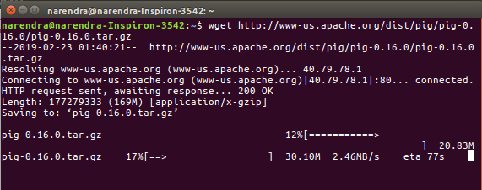
Step 2 :-Extract the tar file using tar command. In below tar command,x means extract an archive file,z means filter an archive through gzip,f means filename of an archive file.

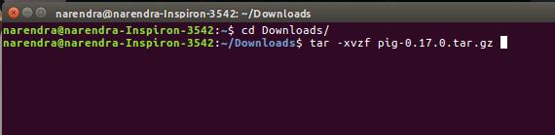
Command: tar -xzf pig-0.16.0.tar.gz

Step 3:-Edit the “.bashrc” file to update the environment variables of Apache Pig. We are setting it so that we can access pig from any directory, we need not go to pig directory to execute pig commands. Also, if any other application is looking for Pig, it will get to know the path of Apache Pig from this file.

Command: gedit ~/.bashrc
Add the following at the end of the file:
export PIG_HOME=/usr/local/pig
export PATH=$PATH:$PIG_HOME/bin

Also, make sure that hadoop path is also set.
Run below command to make the changes get updated in same terminal.
Command: source .bashrc

Step 4:-Check pig version. This is to test that Apache Pig got installed correctly. In case, you don’t get the Apache Pig version, you need to verify if you have followed the above steps correctly.

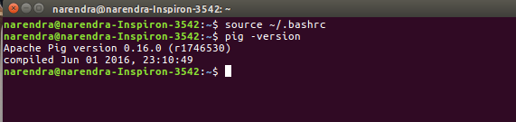
Command: pig -version

Step 5:-Check pig help to see all the pig command options.
Command: pig -help
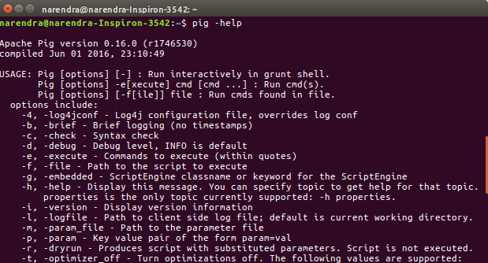
Step 6:-Run Pig to start the grunt shell. Grunt shell is used to run Pig Latin scripts.

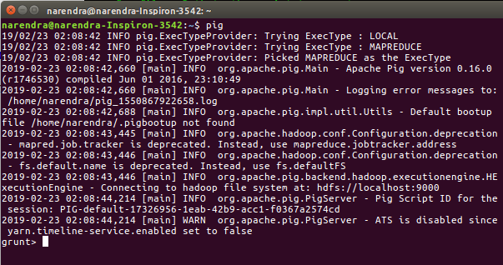
Command: pig
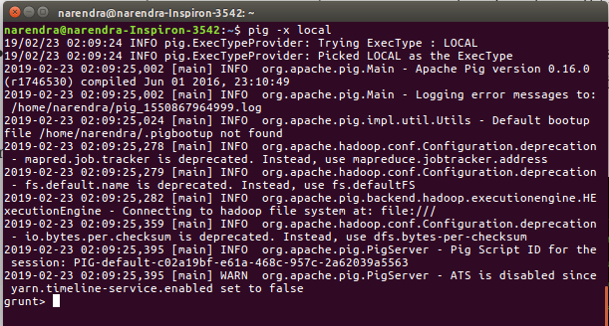
Command: pig -x local

